Picture 1

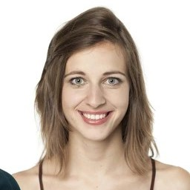

jenny-camera.jpg

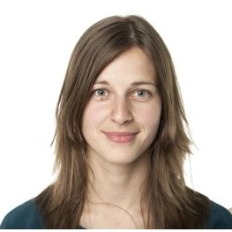

jenny.jpg

Results

-database

-verify()

-who_is_it() / output[2]

